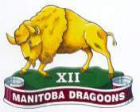

Volume 1, Issue 1 Brandon’s Military Museum November 2011
26 FIELD REGIMENT RCA/XII MANITOBA DRAGOONS MUSEUM• BRANDON MB

The XII Manitoba Dragoons/26th Field Regiment RCA Museum

The museum is a dynamic institution with a corps of highly knowledgeable, committed and dedicated volunteers. The Museum is housed in the historic and important Brandon Armoury building in the centre of the city and is located at the SW corner of 11th Street and Victoria Avenue.

In This Issue:

- History of the Museum

The 99th Manitoba Rangers;
- Units Centennial Cairn and

The 26 Field Regiment RCA

Change of command; 3. Quilt of Valor;

Susan Armstrong, OC;

Dedication Jim Brooks; and 4. Museum Volunteers.

Volunteers
Museum Board President Don Berry, OStJ, CD (Col retired) Museum Board Vice President Rick Felstead, CStJ, CD (Hon LCol) Curator Emeritus Ross Neale, CD (CWO retired) Curator and Newsletter Editor E.L. (Edd.) Mc Arthur, CD, GSM, LSM (Capt retired) Secretary and Chief Researcher Gord Sim, CD Librarian Sandra Armstrong, BA, BLS Treasurer, Educational Coordinator and Collections Manager Lorna Ball, BA, Dip CE, DipSWk William Hillman, B.Sc., B.Ed., M.Ed Webmaster, Editor and Host George Haggerty, CD (Lt Navy retired) Floyd Harrison Reauna Knight Ted Krasicki, CD Bill Mummery Michael O’Hagan Bill Pierson

For Information on Museum and tours be sure to check us out on the web at:
www.26fdregmuseum.com or www.12mbdragoons.com
Or e-mail the following:
Curator Edd. Mc Arthur 26fdregCurator@wcgwave.ca or Edward.McArthur@forces.gc.ca
Secretary/ Head Researcher Gord Sim 26FdRegMuseum@wcgwave.ca
Librarian 26fdlibrary@wcgwave.ca
Or telephone the following:
Office and Library 204 728-2559 ext 238
Curator/Newsletter Editor 204 726-3498
Secretary/Chief Researcher 204 727-7691

This News letter is published by SDI under the authority of the 26 Field Reg/XII MB Dragoons Museum Board. Forward any inquiries to 26fdregCurator@wcg.wave
The 26th Field Regiment RCA Museum was founded in 1979 when LCol Berry decided the regiment needed a formal place to house the artillery artefacts and to recognize the service of the soldiers of the of the unit. At this time the third floor caretaker suite became available and Mr. Ross Neale (CWO retired) former Regimental Sergeant Major was asked to set up the museum. In 2000 the name of the museum was changed to The 26th Field Regiment RCA/XII Manitoba Dragoons Museum to reflect the history of XII Manitoba Dragoons creating the museum we have today. Continued on page 2
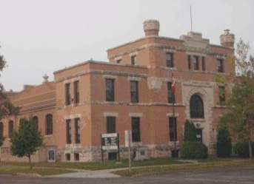

Figure 1 Brandon Armoury opened 1907
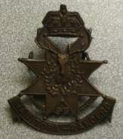
Figure 2 99th Manitoba Rangers Badge

In This Issue
1 | History of the Museum
1 | Units Centennial Cairn
2 | Volunteers3

The 26th Field Regiment RCA perpetuates a number of units and can be traced to the 99th Manitoba Rangers, which were organized in April 1908.
Friends of the Museum who wish to make donation or a bequest of Artefacts or financial assistance to the Museum are always welcome. Please contact the Museum Treasurer, Lorna Ball at rgball@mymts.net or call 204-728-7665

PAGE 2
Continued from page 1

The Museum displays an extensive collection of military artifacts dedicated to the preservation of the history of the servicemen and women of the Brandon area and greater South West Manitoba.
The Purpose of the Museum is to keep alive the memory of those people from South-western Manitoba who served their country in the Canadian Forces through the following: a. to preserve the military history of SW Manitoba and in particular, the history and heritage of the 26th Field Regiment RCA and the XII Manitoba Dragoons. b. to educate the public. Museum volunteers are encouraged to learn the history and to pass on this history to visitors to the museum. c. to maintain and preserve archival records. d. to maintain, catalogue and properly loan out books from the Museum's collection. e. to maintain a website for virtual access to the museum f. to enhance the image of the army, strengthen recruiting and esprit de corps. g. to this end, the museum will collect, preserve research and display military and military related items.
The Units Centennial Cairn was established to recognize the Military Units that served in the Brandon Armoury from 1908 until 2008. The 100th Anniversary of the founding of the 99th Manitoba Rangers a forerunner of the 26th Field Regiment RCA. The XII Manitoba Dragoons formed in 1893 were transferred to the supplementary order of battle in 1964. The 2528 Royal Canadian Army Cadet Corps and the Museum are the only Canadian Forces organizations that perpetuate the name and insignia of the regiment. The Cairn also recognizes the Royal Northwest Mounted Police, the 45th, 71st and 181st Battalions, 1st Battalion Canadian Mounted Rifles, 102nd Reserve Company Veterans Guard of Canada, 59th Field Battery, Royal Canadian Army Service Corps and Brandon’s Sea, Army and Navy League Cadets Corps and Air Cadet Squadron. The Cairn is located on the North East corner of the Armoury.

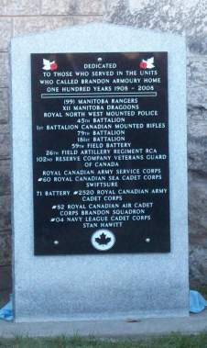

Figure 3 Units Centennial Cairn 1908 to 2008

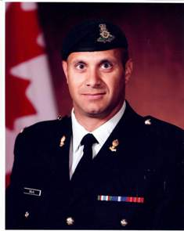
Our congratulations to LCol Dave Dalal, CD, the new Commanding Officer of 26th Field Regiment RCA. LCol Dalal who assumed command of the Regiment on Saturday the 29 Oct 2011 at King OP on the range at CFB Shilo.

The Museum wishes to thank LCol Ross Thompson, CD the former Commanding Officer of 26th Field Regiment RCA, for his support of the Museum during his tenure. We wish him well in his future career.

Figure 4 LCol D.A. Dalal, CD
PAGE 3

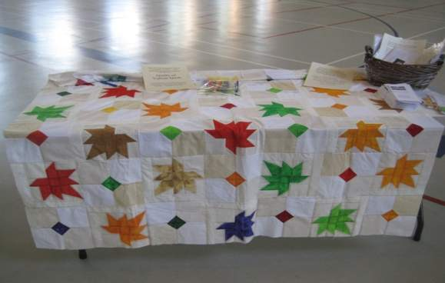

The 26 Fd Regt RCA /XII MB Dragoons Museum sponsored Quilt of Valor on 16-17 July during Brandon Open Doors Historic Tour days. Visitors then and Cadets and visitors since have left a message and signed the quilt. This Quilt of Valor will be given to injured Canadian Forces members and Veterans.

Figure 5 Q.O.V. Brandon at Heritage Days

Susan Armstrong, OC 1952 - 2006
Susan Armstrong, the founding director-general of the Missing Children's Network. Her community work was recognized in 1999 when she received the Order of Canada from the Governor General. Armstrong was made an officer of the Order of Canada in 1999. The OC and QGJM have been generously loaned to the Museum by her Daughter.
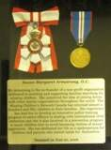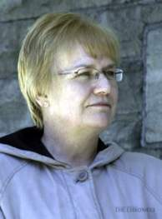

Figure 6 Susan Armstrong Order of Canada and Queen’s Golden Jubilee Medal
This issue of the Newsletter is dedicated to the memory of
Jim Brooks
a dedicated Museum Volunteer and a good friend.

PAGE 4
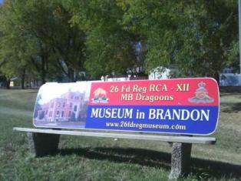
Catch a bus,
Drive a car,
Ride your bike or walk.

The Museum is open every Tuesday from 9:00 am to 4:00 pm closed for lunch. For tours for other times call:
Edd. at 204-726-3498 or
Gord at 204-727-7691.

Figure 7 New Bus Bench on Richmond Avenue East

