26 Field Artillery XII Manitoba Dragoons March 2016 Newsletter

From the Researcher
The museum in late October was contacted by Dianne Cunningham, the daughter of Victor Stilwell after she had contacted the Military Museums of Calgary on the search for her father’s trunk. This search lead form our museum to Holland and finally to Edmonton where the trunk had been since death of Captain Victor Stilwell in 1975, upon the passing of Victor the trunk was given to Arnie Mottershead who had possession of the trunk until donating the trunk to the museum in December of 2015. Two volunteers from the museum made the trip from Brandon to Edmonton to obtain the trunk. The trunk and its contents are now on display within the museum.
Victor Combes Stilwell was born in 1916 at Lena, Manitoba to parents George and Jane Stilwell. Victor was an employee of the T E Eaton’s Company in Winnipeg. He was taken on strength with the 18th Manitoba Reconnaissance Battalion on 1 July 1941 as a Second Lieutenant. Promoted to Lieutenant, 3rd April 1942 as Troop officer with A Squadron. Mr. Stilwell was promoted to Acting Captain on the 9th July 43 and confirmed in the rank of Captain 13th October 1943. Mr. Stilwell was the Second in Command of A Squadron as of 21 June 43 Cpt. Stilwell landed with A Squadron on the 9th of July 1944 with A Sqn in Normandy, France Captain Stilwell was described by Trooper Douglas Fisher as a “Keen, capable, and appreciated officer. A chronic laugher, whose good spirits, and steadiness the squadron depended on.” Captain Stilwell departed the regiment on 17th of September 1945 via No. 455 Draft to return to Canada. Mr. Stilwell returned to Winnipeg and later Edmonton with his wife Eleanor and his position at Eaton’s. He and Eleanor had two daughters Victor died in 1975 at the age of 59 in Edmonton, Alberta.
Awarded Dutch Bronze Lion on the 22 December 1945 for his action during the period of 6 April 45 to 11 April 45 Captain Stilwell in Command of A squadron without a second in command and short of officers. Captain Stilwell was forced to personally go forward and direct the battle. During this period, due to the shortage of officers, Captain Stilwell was subjected to great fatigue due to lack of sleep. At many times subjected to small arms, mortar, and shell fire. In spite of fatigue, enemy fire and the fact that the squadron might have been cutoff at any time due it being extended over such a very long distance, he coolly and skillfully led and directed his squadron in this operation. Captain Stilwell’s leadership, enthusiasm and coolness under fire were an inspiration to his men.
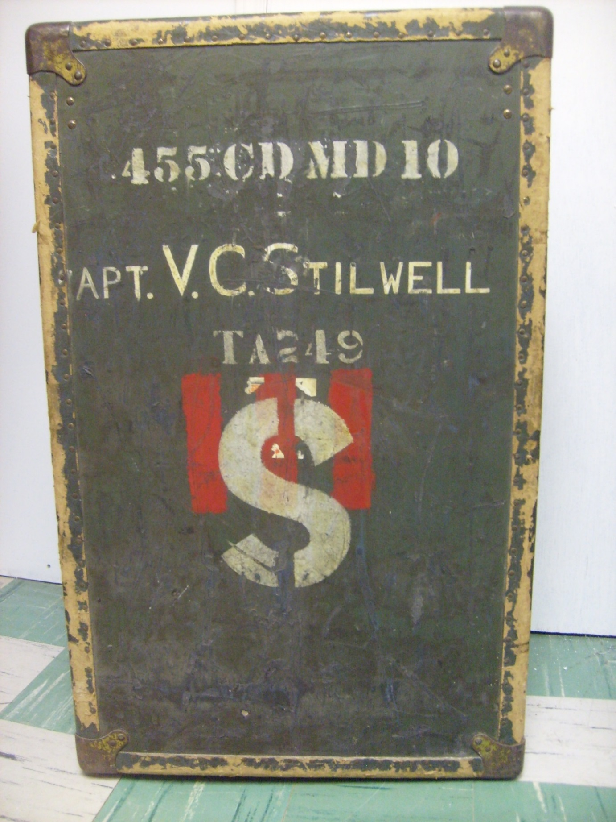The Trunk
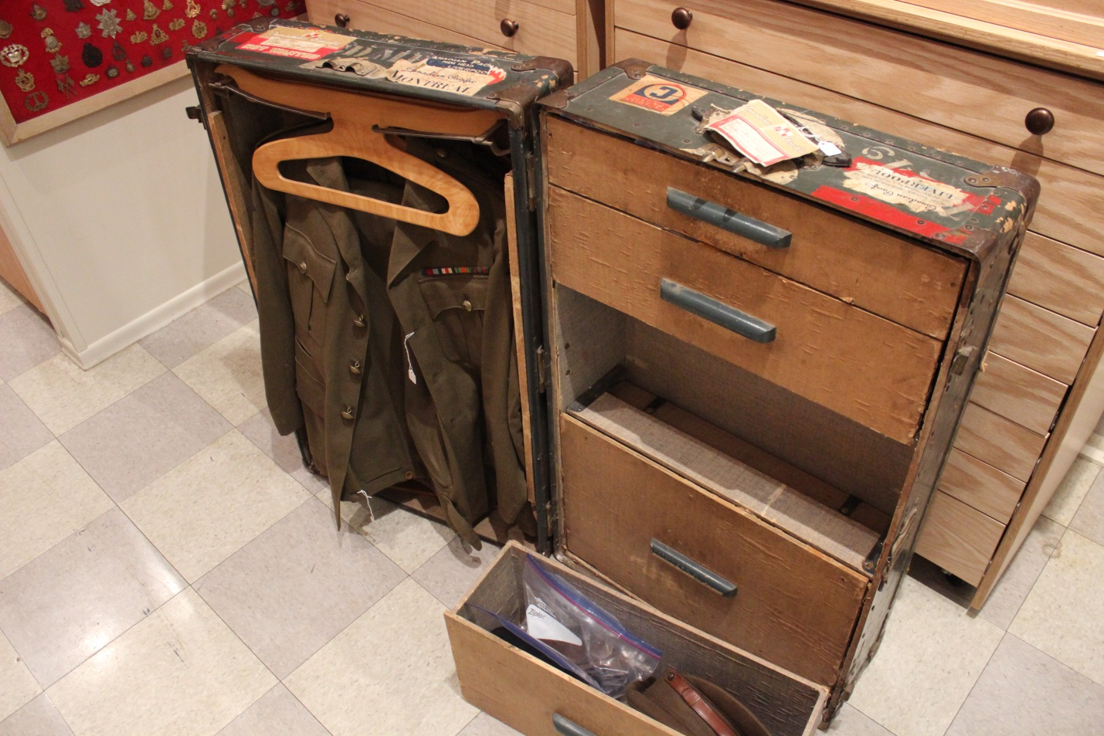Cataloguing the collection
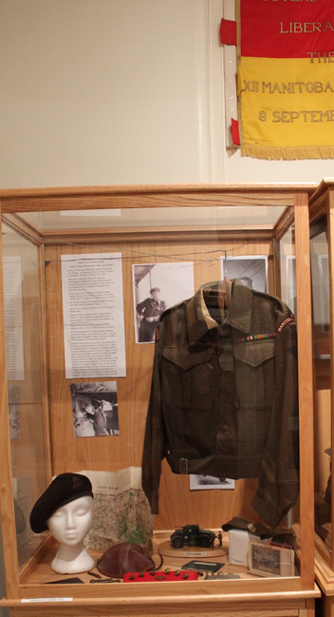

The museum has been involved in an upcoming documentary titled “Then and now: The Life in the Regiment.” The footage available is from the Second World War the film was created by the men of the Regiment during WWII and portrays a various aspects of Regiment from recruiting to fighting overseas. This project is done in cooperation with Graham Street a local filmmaker and instructor with the Interactive Media Arts program at Assiniboine Community College (Brandon, Manitoba) and his great crew of cameramen. Work on this documentary started in early 2015 and since then Graham and crew have been conducting interviews with Veterans of the Manitoba Dragoons. Segments with the museum volunteers have been with everyone from the Curator to the Collections manager, and everyone in between. Segments with subject matter experts have been ongoing as well. Since the start of the project it has steamed along to where it currently sits, as Graham Street had the following to say on the project:
“It has been an excellent experience so far working with the museum on this project. The volunteers are very knowledgeable and the research that has been conducted has contributed greatly to the overall project. 'The most difficult area of research has been the actual locations the film was taken from; as this is a 'Then and Now' project, we need to line up the camera in the exact location the cinematographer was when filming the original. We've been going through the film scene-by-scene and shot-by-shot and then moving to google maps street view to try to pinpoint exactly where the footage was acquired.”
The plan as it is right now is to continue work on the ‘Then and Now’ aspects, finding out more information about the men behind the camera the regiment used, as well as preparing for filming in England, Belgium, Netherlands, and Germany.
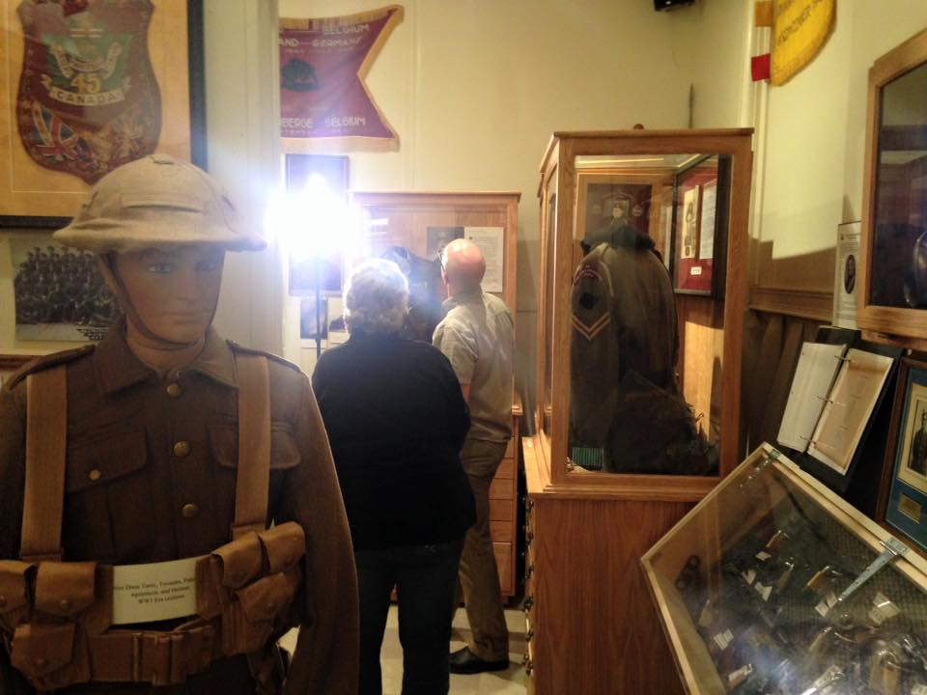Faye Carkner and Graham Street

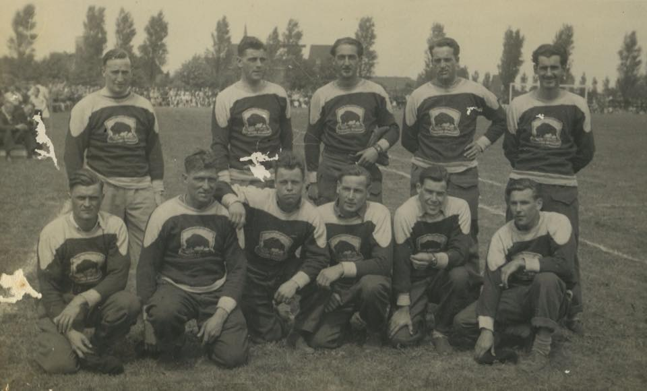
Keith’s Rangers – the Twelve Manitoba Dragoons During World War Two. Can you help name any of these people?

From FOMI

Friends of the Museum is the charitable arm of the Museum. In the past year over $3,700 in monetary donations were received and a further $3500.00 was raised through the Vimy Night fundraiser. The funds are used for the day to day operation of the museum, funding a summer student program and outreach to community events. FOMI also paid for one museum representative to attend the Association of Manitoba Museums (AMM) Conference in Winnipeg and travel costs for one museum representative to attend the Organization of Military Museums of Canada (OMMC) conference in Ottawa.

Vimy night is fast approaching and the goal for this year is to exceed our attendance and funds raised from last year. Vimy Night is April 2nd with the doors to the armoury open at 6pm. Cost is $20.00 per person which includes a Chinese Buffet supper, live auction and a raffle. Our guest speaker this year is Marc George. Please contact Arlene Haggarty at 204-717-4579 or email 26fomi@gmail.com. If unable to attend but wish to make a monetary donation please make cheques payable to “Friends of 26 Field Artillery RCA - XII MB Dragoons Military Museum
Inc”.

Our committee is growing and we are always looking for willing members to join. If interested please contact the museum at 204-717-4579 or 26fomi@gmail.com.

From the Library and Archives

The cataloguing of items continues we currently have 4030 items cataloged and in the library and archives. Check out our website to see the listing of the artifacts, photographs, books and papers that we have in our collection. Currently we have been working on adding manuals from throughout the 20th century.

From The Board
The Annual General Meeting was held on Tuesday February 9, and at this time we said our official farewells to Lorna Ball as the NPF accounts treasurer, to Rick Felstead as our Vice-President and to Gord Sims as our secretary. We wish to extend our thanks to these hard working individuals for their many years of service to the Museum. We are still looking for a treasurer but hope to have that position settled in the near future.
The current board and volunteer staff are
Col. Don Berry (Retired)- Chair
Major Brian Midwinter (Retired)- Vice Chair
Rev. Dr. Glenn Ball – Secretary
___________ - Treasurer
Captain Edd McArthur (Retired) – Curator
Ms. Sandy Armstrong – Librarian
Pte John Ball (Retired)- Researcher
Ms. Faye Carkener – Collections Manager

